App Analysis
The app that I have chosen to review is Steam. This is a fairly popular app on the internet now due to the boom in PC gaming over the years. The primary purpose of this app is to serve as an online marketplace for video games. Think of it as an online version of a GameStop store. This app also serves as a social network to connect gamers so they can play games together. This app has several features that set it apart from other online game vendors. Steam itself has a store page, account pages, community pages as well as their library page that allows you to download and play the games that you purchase. This store page has an exorbitant number of games that you can purchase and play, ranging from AAA games such as Resident Evil to indie games like Undertale. This marketplace allows game fans of all kinds to find content that they would love to play and instantly add it to their account. The intended audience is for PC gamers of all shapes and sizes. Offering games that range from E ratings all the way up to Adults Only ratings.
What The App Does Well
The app itself is on both desktop and mobile and each version is easy to use, clear and has great design. Finding games to play and people to play them with has never been easier. All of the games are presented equally and display tags that allow for the users to find games that share game types with other games. The community tab while not formatted well is a great place to connect, allowing users to share their own content that they take while playing games. Whether it’s videos, screenshots, art, or just message boards. The community tab allows gamers that play the same games to share their own content with other players. These tabs are easily accessible for the average user and allow for clear visibility and user experience. The social tab itself is really good as well. It allows for easy connections between users. The chat is encrypted and stored, and the server connections between two users are efficient. The cloud service is really good so far. It’s the best in business and leaps and bounds ahead of Epic Games and Ubisoft Connect.
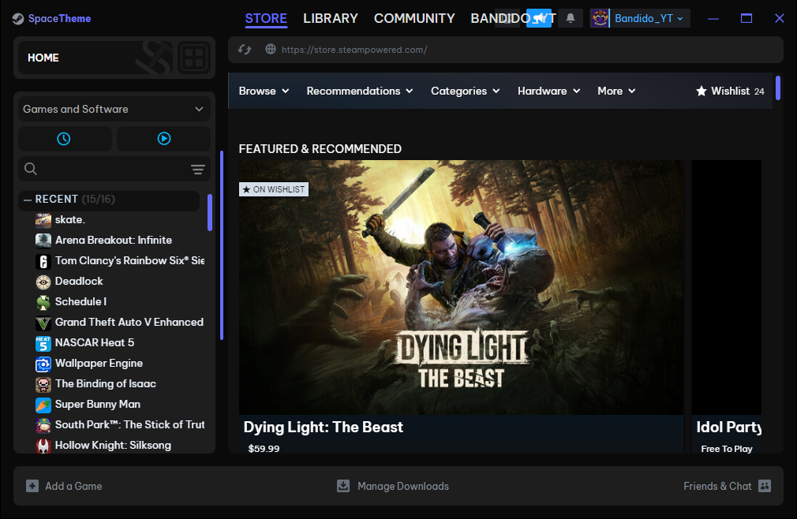
Home Page
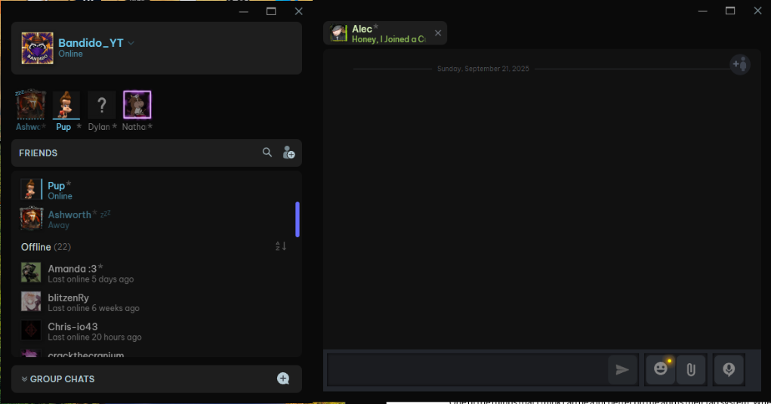
Social Tab
What Could Be Better
One of the things that I think can be a lot better on the app is their tag system. When searching on the store for specific types of games, a beginner might have trouble adding on search terms. While most of us browsing will know what we’re looking for, that’s not the case for most gamers. I’ve found myself just browsing the store using specific tags such as racing or FPS to search for all games that are based on those game genres. Searching the Steam store by tag is decent on PC, but when you make it to the mobile app, there is a massive falloff in user experience. The major thing that I think plays into that is the lack of clear organization. The store itself is pretty well organized, but the user experience on the mobile version is a major step down from the PC marketplace. The only other massive issue I see with the app itself on both mobile and desktop is the community tab. While it’s organized well, I feel like it can be organized better.
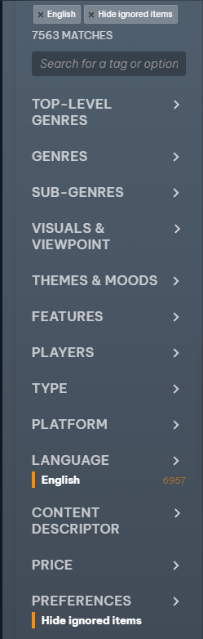
Tag Section. Each section has well over 50 tags.
Two Improvements
On the community tab, all posts are formatted randomly by filling up spots. Instead, I feel like the community tab should be split into different types of content. I think if they were to separate the different forms of media for the community tab, they can create a much more user-friendly experience by grouping content types together. If you’re looking for video, you can just click the video tab. Categorizing the community tab into sections based on the type of content can allow the users in those communities to consume the content they want. In terms of app or UI design, having everything be a massive jumble is a good way to deteriorate the user experience by flooding them with content they don’t really want to see. Limiting that can allow for a better experience and create a cleaner and more efficient user browsing experience. The other change that I would clamor for would have to be the store search tag system. In my opinion, steam itself has tried so hard to categorize their store page to the point where they’ve oversaturated the number of tags. Instead of 15-20 distinct tags that can pertain to multiple different games, they have expanded their tag list to well over 300 different tags. Some of these tags serve no purpose and can be integrated into other tags. Things like “World War 1” and “World War 2” can always be slipped into the “War” category. Steams tag system is clearly way too expanded and needs to be condensed massively to help streamline the user experience. While I do understand the reasoning for having a lot of highly unique tags for products, for the most part the majority of them are unnecessary and can just be merged into other tags to streamline the user interface and the user experience.
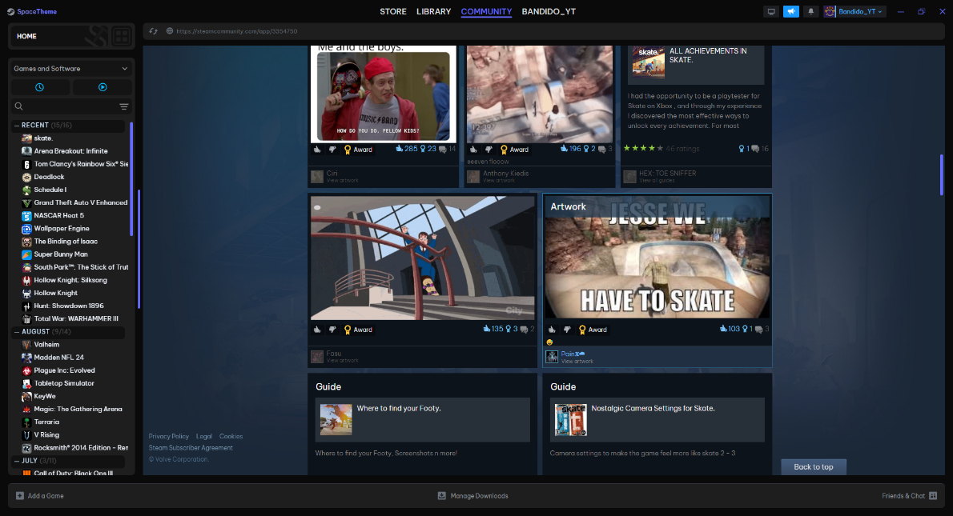
Community Tab with random assortment of content
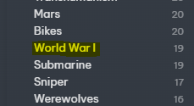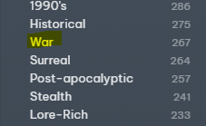
Example of Tags that Can be Merged Together
End-User Documentation
For this documentation, we will learn how to change the parental controls for store content that is suggested to the account. Steam has a cool feature where it will suggest games to you if you play games that might share a genre, but sometimes this can lead to harmful content being shown to the wrong audience. Keep in mind that Steam does have some games that feature adult content and are listed for Adults Only, but with no real age verification, that content can find the wrong audiences without proper moderation by parents. Today I will show you how to lock out any content that you don’t want underage users to see. We are going to follow some small steps, that are as follows:

- Open the Steam App.


- Find the settings tab on the top of the client window.
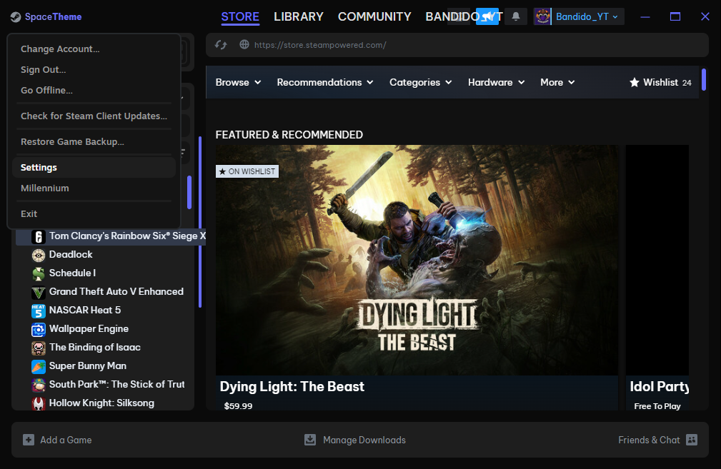

- Go to the Store tab on the settings window.
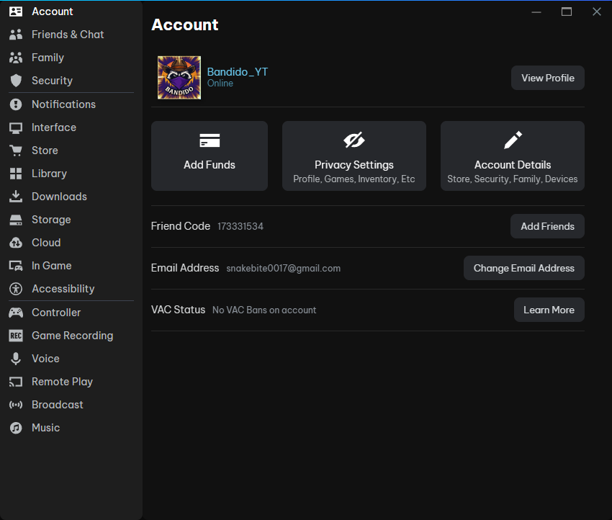

- Find the Mature Content filtering button and click it.
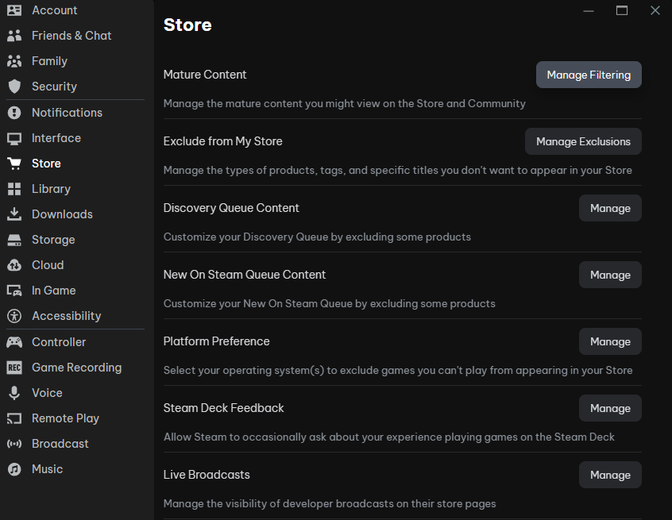
- Select (or deselect) the content that you don’t want to be present in the store.
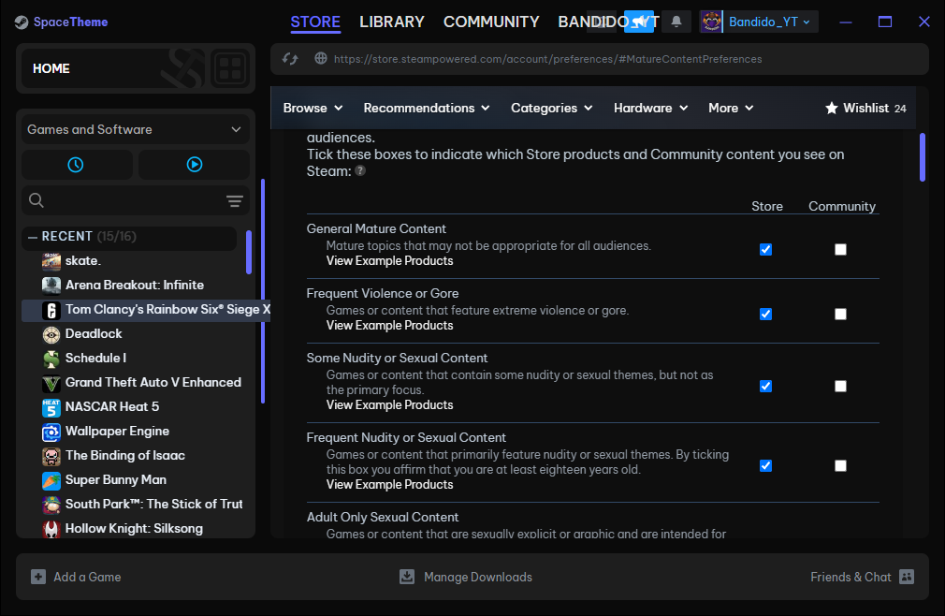
- Confirm and then close the window.
By following these steps, you will have blocked content that you don’t want your child to see. If at any time you want to relax with the guidelines, you can always go back in and re-select the boxes to see that content again. Hopefully this guide was helpful. Thank you for using Steam and making it a safe environment for your child.

